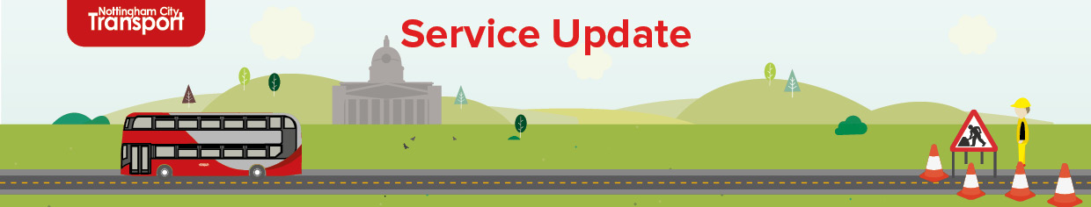

|  |  |
| --- | --- |
| **Date:** | 28/JUL/2025 |
| **Ref:** | SU148 |
| **Display Until:** | 05/AUG/2025 |

**Outbound closure of A610 Nuthall Road (4)**

Contractors working on behalf of Nottingham City Council are undertaking works that require the full outbound closure of Nuthall Road from Bar Lane to Stockhill Lane.

From **Wednesday 30th July ‘25** until **Monday 4th August ‘25**

**(from appx. 09:00 until 17:00 weekdays - 08:00 until 17:00 weekends)**,

services 79/79A/79B will divert via:

**Services 79/79A/79B to Bulwell/Rise Park/Arnold**

Operate via normal routes as far as Nuthall Road, then at the junction with Bar Lane / Melbourne Road turn RIGHT Bar Lane, left Percy Street to mini island continue on Stockhill Lane and then continue on Broxtowe Lane to resume normal route.

**Services 79/79A to City**

Operate via normal routes.

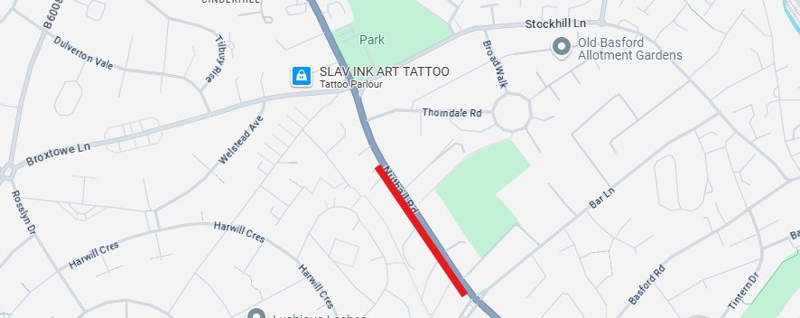

Lee McClory

Service Planning Manager