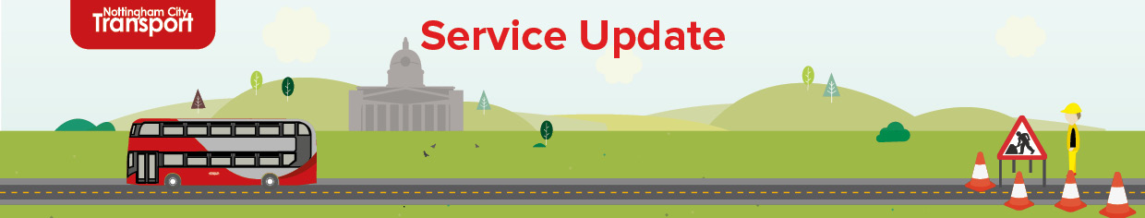

|  |  |
| --- | --- |
| **Date:** | 28/JUL/2025 |
| **Ref:** | SU149 |
| **Display Until:** | 20/AUG/2025 |

**Outbound closure of A610 Nuthall Road (6)**

Contractors working on behalf of Nottingham City Council are undertaking works that require the full outbound closure of Nuthall Road from the Ring Road to the junction of Bar Lane.

From **Tuesday 5th August 2025** until **Friday 8th August 2025** and

**Monday 11th August 2025** until **Tuesday 19th August 2025**

**(from appx. 09:00 until 17:00 weekdays – 08:00 until 17:00 weekends)**,

services **78** & **79/79A** will divert as follows:

**Services 78 & 79/79A/79B to City**

Operate via normal routes.

**Service 78 to Strelley**

Operate via normal route to Bobbers Mill Bridge, then run via left Aspley Lane, right Melbourne Road & left Hilcot Drive to normal route.

**Services 79/79A/79B to Bulwell/Rise Park/Bulwell**

Operate via normal route to Bobbers Mill Bridge, then run via left Aspley Lane, right Melbourne Road & left Bar Lane to normal routes.

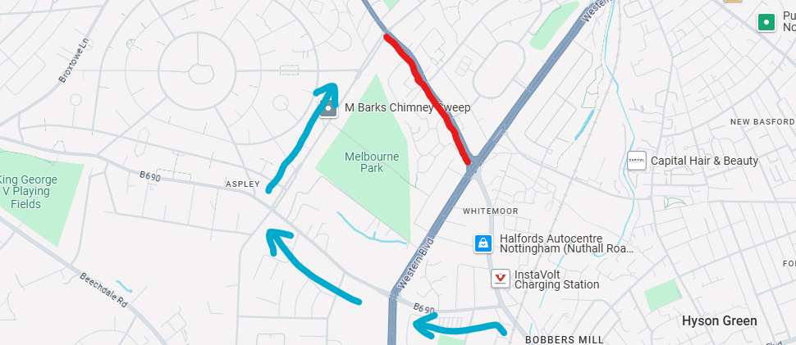

Lee McClory

Service Planning Manager