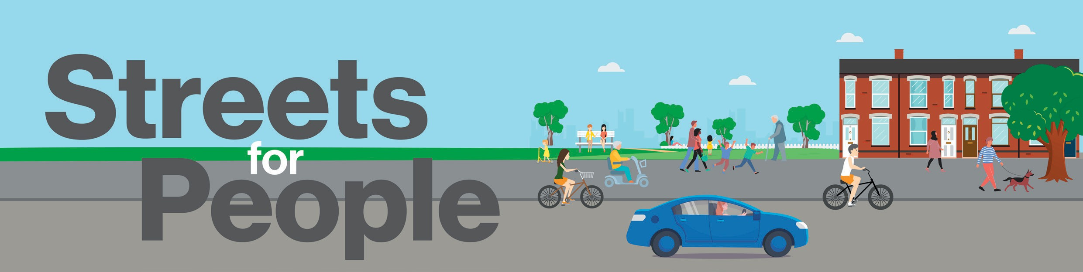

June 2026

Nottingham City Council is improving your road

On 22nd June we will commence a retread programme on the following roads. Each road will be closed to traffic between the hours of 8am to 5pm on the dates below, diversion routes will be in place where required.

Street Name: | Start Date: | End Date:
Bestwood Road | 22/06/2026 | 25/06/2026
Devonshire Road | 26/06/2026 | 29/06/2026
Watcombe Circus | 30/06/2026 | 03/07/2026
Watcombe Road | 03/07/2026 | 06/07/2026
Lucknow Drive | 07/07/2026 | 14/07/2026
Langdale Road | 15/07/2026 | 17/07/2026
Totnes Road | 20/07/2026 | 20/07/2026

If you have any general questions or concerns or require additional assistance during the works, please contact us at
highwaymaintenance@nottinghamcity.gov.uk. If you have any immediate site concerns whilst works are taking place, please call the contractor, Colas Limited , on 01476 404200




Funded by the East Midlands
Combined County Authority (EMCCA)

